Nairobi, Samburu & Great Rift Valley Golf Safari

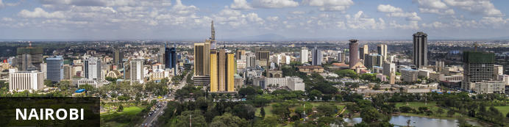
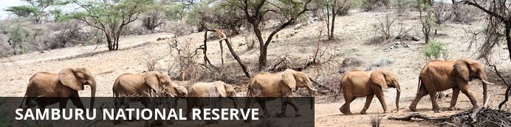
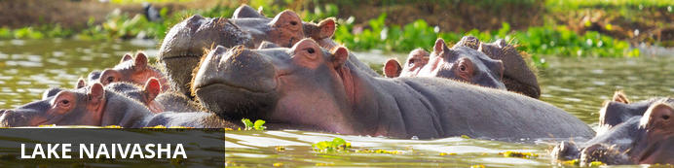
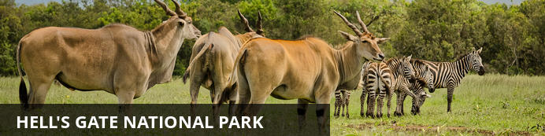

Nairobi, Samburu & Great Rift Valley Golf Safari
Nairobi - Samburu National Reserve - Lake Naivasha
8 Days / 7 Nights
0 Persons
Reference: Kenya Open Golf Package 2
Date of Issue: 14 February 2019

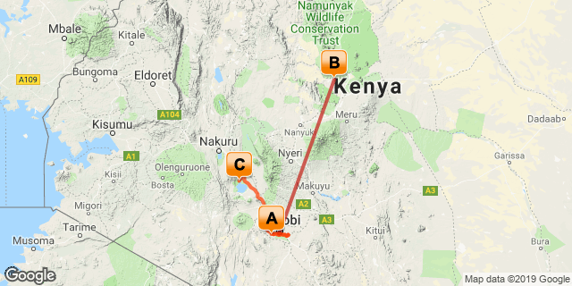

Click here to view your Digital Itinerary

Introduction
This 8-Day Golf Safari takes you from Nairobi's top Golf course to the Samburu National Reserve which is teeming with wildlife followed by 3-Days of Golf at the phenomenal Champion Course at the Great Rift Valley Lodge with excursions to Naivasha's most popular parks and attractions. This 8-Day itinerary offers visitors a well-rounded tour of Kenya and a unforgettable experience.

Accommodation | Destination | Basis | Duration
The Residences at Karen | Nairobi | B&B | 2 Nights
Samburu Intrepids Tented Camp | Samburu National Reserve | FB | 2 Nights
Great Rift Valley Lodge & Golf Resort | Lake Naivasha | FB | 3 Nights

Key
B&B: Bed and Breakfast
FB: Dinner, Bed, Breakfast and Lunch

Price
Safari price:- US$ 2135 per person sharing
Single supplement:- US$ 455

Included
Included in the price:-
-Transportation including all arrival and departure airport transfers .
-Entrance fees & Green fees
-Services of professional English speaking guide
-Game drives as per itinerary
-Return flight Nairobi/Samburu/Beach Nairobi
-Accommodation on BB while in Nairobi and full board while on tour
-Flying Doctors Service for emergency evacuation cover in case of sickness or accident.
-Public Liability cover

Excluded
Not included in the price:-
-Caddy fees at $10 per round of 18holes
-Golf cart hire
-All personal expenses like water, drinks, souvenirs and toiletries
-All optional excursions fee/ entrance fees
-Personal travel/ Medical insurance
-International and domestic flights
-All airport taxes and visas
-Any other extras not stated as included above

Day 1: The Residences at Karen, Nairobi

Day Itinerary
Meet and greet at the Airport in Nairobi, from here you will be driven to The Residences at Karen Country Club , Enjoy Lunch at the Club overlooking the beautiful Fairway followed by an optional 18-Hole round of Golf or a relaxed afternoon. Dinner at the Club.

Nairobi
Situated in along the Nairobi River in beautiful Kenya, the capital of Nairobi is East Africa's most cosmopolitan city. It serves as an excellent starting point for African safari trips around Kenya. Nairobi is Africa’s 4th largest city and is a vibrant and exciting place, and although it has developed a reputation which keeps tourist visits brief, there are some fascinating attractions: its cafe culture, unbridled nightlife, the National Museum, the Karen Blixen Museum and most notably just 20 minutes from the city centre wild lions and buffalo roam in the world’s only urban game reserve. Make sure you pay a visit to the elephant orphanage operated by the David Sheldrick Wildlife Trust.

Overnight: The Residences at Karen
Tucked away in a Pleasant forested area overlooking the second hole of the golf course, The Residences at Karen embody comfort, luxury and serenity, perfect for any getaway. Guests will be able to wake up to the vast bird life chirping away welcoming the morning. The word "Residence" only hints at the level of luxury and personalized service which will greet one at the Residences at Karen, it is truly home away from home. The team of professional staff is eager to serve you and anticipate your every need. Created for use by our members and their guest, The Residence host six - two bedroom cottages and twelve apartment suites. The Residence is perfect for entertaining out-of-town family, friends and executives or for personal getaways.
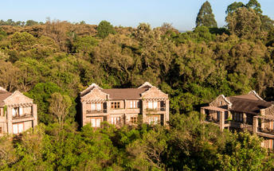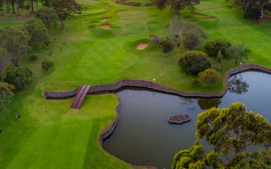

Optional
Golf Round

Karen Country Club Golf Course
Karen Country Club was founded in 1937 and boasts being one of the oldest golf clubs in Kenya. The country club features an 18 hole golf course, restaurant, spa and nail bar and accommodation facilities that overlook the second hole of the golf course.
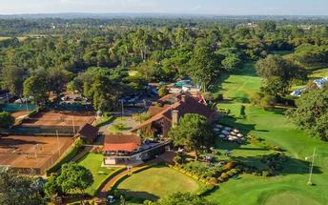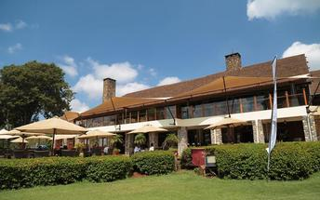

Basis
Bed & Breakfast

Day 2: The Residences at Karen, Nairobi

Day Itinerary
Breakfast at the Club followed by a morning 18-hole round of Golf on the Par 72 course followed by Lunch at the Club. In the Afternoon enjoy a excursion to either the Giraffe Centre where you can hand feed Rothschild Giraffes or the David Sheldrick Wildlife Trust where you can meet and interact with orphaned elephant calfs. Dinner at the Club.

Activities
Round of Golf

Optional
Afternoon | Giraffe Centre
Afternoon | The David Sheldrick Wildlife Trust

Karen Country Club Golf Course
Karen Country Club was founded in 1937 and boasts being one of the oldest golf clubs in Kenya. The country club features an 18 hole golf course, restaurant, spa and nail bar and accommodation facilities that overlook the second hole of the golf course.

Giraffe Centre
The African Fund for Endangered Wildlife Kenya (A.F.E.W. Kenya) also known as the Giraffe Centre is a non-governmental, non-profit making organization, which was founded by Betty and Jock Leslie-Melville in 1979. This was in a bid to save the endangered Rothschild Giraffe, which had lost its natural habitat in Western Kenya to agriculture and there were only 130 left in the wild. Funds were raised and 4 herds of the Rothschild giraffes were moved to 4 parks namely Lake Nakuru National Park, Mwea Game Reserve, Ruma National Park and Nasalot Game Reserve.
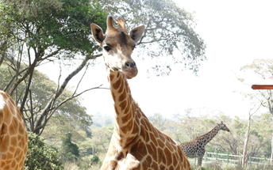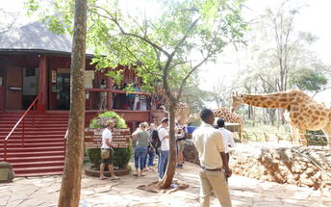

The David Sheldrick Wildlife Trust
Founded in 1977 by Dr. Dame Daphne Sheldrick D.B.E, in honor of the memory of her late husband, famous naturalist and founding Warden of Tsavo East National Park, David Leslie William Sheldrick MBE, the DSWT claims a rich and deeply rooted family history in wildlife and conservation. Born from one family’s passion for Kenya and it's wilderness, the David Sheldrick Wildlife Trust is today the most successful orphan-elephant rescue and rehabilitation program in the world and one of the pioneering conservation organisations for wildlife and habitat protection in East Africa.
To date the David Sheldrick Wildlife Trust has successfully hand-raised over 150 infant elephants and has accomplished it's long-term conservation priority by effectively reintegrating orphans back into the wild herds of Tsavo, claiming many healthy wild-born calves from former-orphaned elephants raised in care.
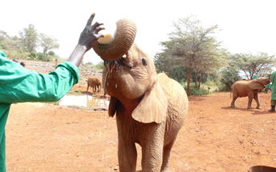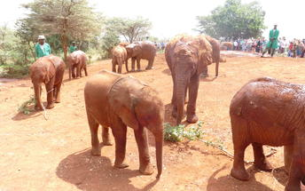

Basis
Bed & Breakfast

Day 3: Samburu Intrepids Tented Camp, Samburu National Reserve

Day Itinerary
Early Breakfast at Karen Country Club followed by checkout. Transfer from Nairobi to Wilson Airport where you will take a flight to Samburu National Reserve where you will stay at the Samburu Intrepids camp. After arrival enjoy a late lunch followed by a late afternoon Game Drive at the Samburu National Reserve which is home to Elephants and large predators such as Lions and Cheetah's, the reserve is also home to diverse species of birds and rare northern wildlife such as the Somali Ostrich and Reticulated Giraffe.

Samburu National Reserve
Resting on the banks of the Ewaso Ng'iro River and neighbouring the Buffalo Springs National Park, Samburu National Reserve is remote, hot and arid. The reserve spans over 165 square kilometres of spectacularly scenic landscape featuring rugged hills, undulating plains and riverine forests. The park is home to abundant wildlife including a variety of rare species such as the reticulated giraffe, the long necked gerenuk, Somali ostrich, Grevy's Zebra and Beisa Oryx. Samburu was one of the homes of 'Elsa the Lioness', star of the best selling book and award-winning movie 'Born Free'. Visitors can enjoy viewing over 900 elephants, a variety of predators, and over 450 bird species.

Overnight: Samburu Intrepids Tented Camp
Dry, rugged and stunning, Samburu’s landscape is at once stark and sensual, with its iconic loaf shaped Lolokowe Mountain and hills spreading in every horizon. Its life lung is the Usao Nyiro River coursing through its craggy terrain full of stone, thorn bush and the forked doum palms. In this arid zone where water is scarce and the land baked by the eternal sun, herds of elephants and the big cats roam the plains with the Samburu special - the Reticulated giraffe, Grevy’s zebra, Beisa oryx, Somali ostrich and the long necked antelope, the gerenuk easily seen despite its harsh climes.
Located 345 kilometres north of Nairobi, the journey to the camp involves a 50-minute flight to the Samburu airstrip followed by a 20-minute drive through the reserve.
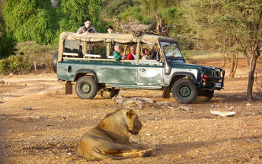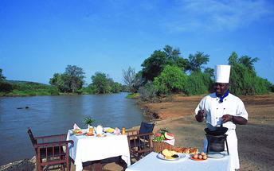

Activities
Afternoon | Game Drive

Samburu National Reserve
Resting on the banks of the Ewaso Ng'iro River and neighbouring the Buffalo Springs National Park, Samburu National Reserve is remote, hot and arid. The reserve spans over 165 square kilometres of spectacularly scenic landscape featuring rugged hills, undulating plains and riverine forests. The park is home to abundant wildlife including a variety of rare species such as the reticulated giraffe, the long necked gerenuk, Somali ostrich, Grevy's Zebra and Beisa Oryx. Samburu was one of the homes of 'Elsa the Lioness', star of the best selling book and award-winning movie 'Born Free'. Visitors can enjoy viewing over 900 elephants, a variety of predators, and over 450 bird species.
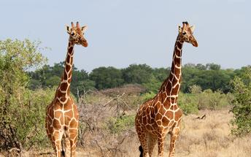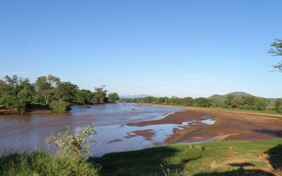

Basis
Full Board

Day 4: Samburu Intrepids Tented Camp, Samburu National Reserve

Day Itinerary
After Breakfast you shall go on a morning Game Drive at the Samburu National reserve followed by lunch, in the afternoon you can incorporate a cultural tour to the Samburu villages for a chance to learn more about the Samburu's rich culture. Dinner at the Camp

Activities
Game Drive

Recommended
Samburu Village Cultural Tour

Samburu National Reserve
Resting on the banks of the Ewaso Ng'iro River and neighbouring the Buffalo Springs National Park, Samburu National Reserve is remote, hot and arid. The reserve spans over 165 square kilometres of spectacularly scenic landscape featuring rugged hills, undulating plains and riverine forests. The park is home to abundant wildlife including a variety of rare species such as the reticulated giraffe, the long necked gerenuk, Somali ostrich, Grevy's Zebra and Beisa Oryx. Samburu was one of the homes of 'Elsa the Lioness', star of the best selling book and award-winning movie 'Born Free'. Visitors can enjoy viewing over 900 elephants, a variety of predators, and over 450 bird species.

Basis
Full Board

Day 5: Great Rift Valley Lodge & Golf Resort, Lake Naivasha

Day Itinerary
Early Breakfast at the camp followed by Check-out. You will then drive form Samburu to Lake Naivasha where you will stay at The Great Rift Valley Lodge. On arrival enjoy a late lunch followed by an 18-hole round of Golf on the phenomenal Champion Course, after Golf enjoy the rest of the afternoon at leisure until Dinner which will be at the Lodge.

Lake Naivasha
Lake Naivasha is the highest of the Great Rift Valley Lakes and despite having no outlet, it is one of only two Rift Valley freshwater lakes. This beautiful lake is fringed by papyrus and acacia trees, a unique geologic landscape and supports a vast array of over 450 bird species. It serves as the main drinking hole for wildlife in the area such as zebra, eland, hippo, waterbuck, buffalo and much more. Visitors can look forward to excellent game viewing, intriguing night safaris, boating excursions around the lake as well as to Crescent Island for spectacular bird watching opportunities. Other popular activities include: guided nature walks, horse riding, village visits and tours to neighbouring national parks.

Overnight: Great Rift Valley Lodge & Golf Resort
The Great Rift Valley Lodge & Golf Resort enjoys one of the most spectacular views in all of Africa, just an hour-and-half's drive from Nairobi. It is perched on the side of the Eburu Escarpment, overlooking the glistening waters of Lake Naivasha and the sweeping floors of the Great Rift Valley of Kenya.
With an 18-hole golf championship course, conference facilities, Adventurers' club activities, swimming pool, activities including horse riding to Eburu forest, mountain biking, team building, this hotel is a must do for all. Accommodation is offered in hotel rooms, classy Longonot Villas and private chalets.
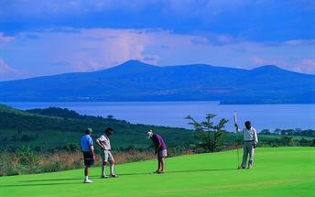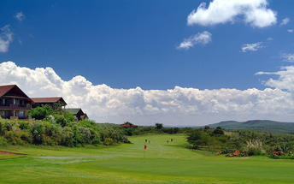

Activities
Round of Golf

Great Rift Valley Golf Course
Overlooking Lake Naivasha and the lush plains of the Great Rift Valley, the Great Rift Valley Golf Course is encompassed by the luxurious Great Rift Valley Lodge and Golf Resort. It offers 18 challenging holes and is rated as one of the best courses in Kenya. When guests aren’t busy playing golf, they can relax by the swimming pool, go bird-watching, hiking, horse-riding, or on game-viewing safaris.

Basis
Full Board

Day 6: Great Rift Valley Lodge & Golf Resort, Lake Naivasha

Day Itinerary
Breakfast at the Lodge followed by a challenging and exciting 18-Hole round of Golf on the Championship Course , after Golf enjoy Lunch at the Lodge followed by an optional visit to Hell's Gate National Park for a Hike /Mountain Biking or go for a Game Walk at Crescent Island Game Park for a unique walking safari. you could also spend the afternoon at leisure on the Lodge grounds enjoying a cocktail or just taking it easy.

Activities
Morning | Round of Golf

Optional
Afternoon | Hell's Gate National Park
Afternoon | Crescent Island Game Sanctuary

Great Rift Valley Lodge & Golf Resort
The Great Rift Valley Lodge & Golf Resort enjoys one of the most spectacular views in all of Africa, just an hour-and-half's drive from Nairobi. It is perched on the side of the Eburu Escarpment, overlooking the glistening waters of Lake Naivasha and the sweeping floors of the Great Rift Valley of Kenya.
With an 18-hole golf championship course, conference facilities, Adventurers' club activities, swimming pool, activities including horse riding to Eburu forest, mountain biking, team building, this hotel is a must do for all. Accommodation is offered in hotel rooms, classy Longonot Villas and private chalets.

Hell's Gate National Park
Located northwest of Nairobi, south of Lake Naivasha, Hell's Gate National Park gets its name from its pair of massive red tinged cliffs which frame its natural hot geysers. The spectacular scenery, complete with rock towers, volcanoes, and geysers with plumes of geothermal steam, is dominated by these sheer cliffs. Visitors can look forward to a wide variety of activities such as: biking through this beautiful landscape, exploring the Njorowa Gorges, discovering two extinct volcanoes – Olkaira and Hobley’s, and camping under the sparkling Kenyan night sky. Popular activities include: walking safaris, mountain biking, rock climbing, hiking and game viewing. Commonly spotted wildlife include: giraffe, zebra, eland, gazelle, buffalo, zebras, hartebeests, baboons and over 100 bird species.
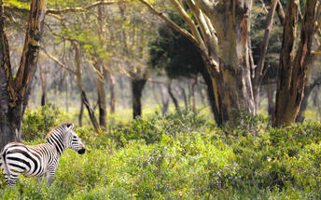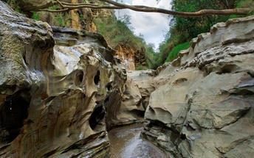

Crescent Island Game Sanctuary
There is just one “Crescent Island Game Park”. Located on Lake Naivasha, Kenya in the Great Rift Valley. It is one of the most beautiful parks in Kenya and is Naivasha’s best-kept secret. Guides are on a first come first serve basis, for whom there is no charge, but they should be given a tip. Surrounded by water, it is actually a peninsula and is accessible by boat from East or West as well as by road. From the top of the hill, there is a 360-degree view across the Lake from Longonot to Hell’s Gate to the Mau Escarpment to Eburu and onto the Aberdares. Walking along the ridge in the golden hour before sunset whilst watching the animals grazing with the water shimmering beyond, is what Africa is all about.

Basis
Full Board

Day 7: Great Rift Valley Lodge & Golf Resort, Lake Naivasha

Day Itinerary
After Breakfast enjoy a 18-hole round of Golf in the morning followed by Lunch at the Lodge. Spend the afternoon in leisure at the lodge enjoying the lodge grounds with opportunities to swim, play tennis or go for a nature walk at Eburu forest a 8,715.3 Hectare indigenous forest. Following afternoon activities enjoy dinner at the lodge.

Activities
Round of Golf
Eburu Forest Nature Walk

Great Rift Valley Lodge & Golf Resort
The Great Rift Valley Lodge & Golf Resort enjoys one of the most spectacular views in all of Africa, just an hour-and-half's drive from Nairobi. It is perched on the side of the Eburu Escarpment, overlooking the glistening waters of Lake Naivasha and the sweeping floors of the Great Rift Valley of Kenya.
With an 18-hole golf championship course, conference facilities, Adventurers' club activities, swimming pool, activities including horse riding to Eburu forest, mountain biking, team building, this hotel is a must do for all. Accommodation is offered in hotel rooms, classy Longonot Villas and private chalets.

Basis
Full Board

Day 8: End of Itinerary

Day Itinerary
Early Breakfast at the Lodge followed by Check Out. Transfer from Naivasha to Nairobi from where you will be transferred to Jomo Kenyatta International Airport for your Flight back home. End of Safari.

Basis
Bed & Breakfast

Transport

Flight Information
Date | Flight | Airline | Departure Airport | Time | Arrival Airport | Time | Class | Ref
 | Scheduled |  | Wilson Airport [WIL] |  | Samburu Intrepids Tented Camp
 | Scheduled |  | Samburu Intrepids Tented Camp |  | Wilson Airport [WIL]

Transfers
Date | Company | Pick Up | Drop Off | Time | Vehicle
 |  | Jomo Kenyatta International Airport [NBO] | The Residences at Karen |  | Transfer
 |  | The Residences at Karen | Wilson Airport [WIL] |  | Transfer
 |  | Wilson Airport [WIL] | Great Rift Valley Lodge & Golf Resort |  | Transfer
 |  | Great Rift Valley Lodge & Golf Resort | Jomo Kenyatta International Airport [NBO] |  | Transfer

Urgent Contact Numbers
Company Name | Telephone | Email Address | Contact Person
Designer Tours and Travel | 0723510448 | mutuma@designersafari.co.ke | Mutuma Koome

Service Provider Directory
Service Provider | Ref. Number | Telephone | Address
Great Rift Valley Lodge & Golf Resort |  | +254 20 2103454 | Heritage House, Waiyaki Way (Westlands), between David Osieli & Mvuli Roads
The Residences at Karen |  | +254 708 505050 | Karen Road  PO Box 24816 00502  Nairobi, Kenya

Travel Information
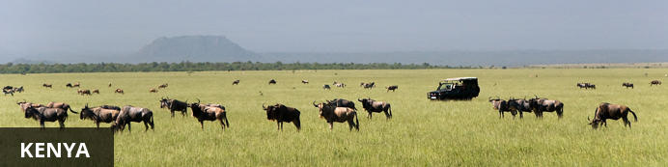
Resting in the magnificent Great Rift Valley and presided over by the majestic Mount Kilimanjaro, Kenya is characterised by hauntingly beautiful natural landscapes of forested hills, patchwork farms, wooded savanna and vast forests brimming with an extraordinary abundance of wildlife. The nation’s diverse range of traditional African cultures is influenced by over 70 unique ethnic groups from the Maasai, Samburu, Kikuyu, and Turkana tribes to the Arabs and Indians that settled on the coast. Add to this: an exquisite tropical coastline fringed with breathtaking golden sand beaches; gorgeous coral gardens providing excellent snorkeling and diving opportunities; and a slew of lively beach resorts, and it is easy to see why so many visitors flock here from around the world to experience a truly unique African adventure in one of the world’s most pristine safari destinations.

Banking and Currency
Currency
The currency in Kenya is the Kenyan Shilling (KES; symbol KSh). 1 Kenyan Shilling = 100 cents. Notes are in denominations of KSh1,000, 500, 200, 100 and 50. Coins are in denominations of KSh20, 10 and 5.
Foreign currency can be exchanged at the major banks, bureaux de change or authorised hotels. The banks at Jomo Kenyatta International Airport and Moi International Airport have 24-hour exchange services. The easiest currencies to exchange are US Dollars, Pounds Sterling and Euros.
There are no restrictions on the import or export of local or foreign currency. However, amounts exceeding US$5,000 or equivalent must be declared.
Banking
Banking hours: Monday-Friday 09h00-16h00, Saturday 09h00-12h00. Banks in Mombasa and the coastal areas typically open and close half an hour earlier.
Credits Cards are widely accepted in all major hotels and more upmarket establishments, with the most recognized being Master Card and Visa. American Express and Diners Club cards are occasionally accepted. However, you will need some cash handy because smaller shops will only accept cash.
Almost every bank now has an ATM, and they are increasingly being installed at petrol stations in cities and large towns.
Travellers cheques are no longer accepted in Kenya.

Travel, Transport and Getting Around
Nairobi has two airports for domestic and regional flights: Jomo Kenyatta International Airport and Wilson Airport (www.kaa.go.ke). Kenya has over 150 domestic airports and airstrips and there are daily flights to the most popular destinations. In addition to the scheduled airlines, several private charter companies operate out of Wilson Airport.
Kenya Airways (www.kenya-airways.com), Air Kenya (www.airkenya.com), Fly 540 (www.fly540.com), Mombasa Air Safari (www.mombasaairsafari.com) and Safarilink (www.flysafarilink.com) serve the most popular safari destinations, plus many others such as Lake Victoria.
On smaller, domestic planes the baggage allowance is restricted to 10-15 kg (22-33 lbs). Arrangements can be made to leave excess luggage with hotels or airlines.
Main roads between the major cities and towns are generally in good condition, and easily navigable in a normal saloon car. Most highways in the south are paved, but that’s not the case in the north.Vehicles are driven on the left side of the road.
While major roads are generally in a good condition, most minor gravel roads have deep potholes which deteriorate further in the rainy season. Dirt roads, including those in the parks and reserves, are extremely rough, and some are only passable with a 4-wheel drive.
You can hire self-drive and chauffeur-driven cars from travel agents and international hire companies. Drivers must be at least 23 years of age. Budget (www.budget.com) and Europcar (www.europcar.com) have outlets at Jomo Kenyatta International Airport in Nairobi. Budget also has a desk at Moi International Airport in Mombasa, while Europcar has an office in town. Car hire can be expensive and rates vary significantly.
A driving licence from a home country (and a translation if this is not in English) or an International Driving Permit is required. Third-party insurance is mandatory when hiring a car and it’s recommended to take out the additional collision damage waiver. A valid credit card is also needed.
Matatus (shared minibus taxis) hop from town to town, starting and finishing at bus stations. Fares are paid to the conductor. Private taxis can also be hired for long-distance journeys.
It is not possible to rent motorbikes or mopeds but some of the beach resorts hire out bicycles.
Numerous private bus companies operate in Kenya. Most vehicles are old and tend to depart when full, which means there are no set timetables. Petty theft on the vehicles and at bus stations can be a problem. Nevertheless, buses are cheap and link all long-distance destinations. Plus, seatbelts are now mandatory, so buses are relatively safe.
Nairobi and Mombasa have efficient local bus systems and there are also frequent matatus, but reckless driving and petty theft makes them a dodgy option for tourists. Three-wheeled auto rickshaws are popular in town centres and carry up to three passengers.
The newer fleets of taxis (usually painted white with a yellow band) are reliable and have meters. The older yellow taxis do not have meters, so fares should be agreed in advance. In Nairobi, there is a fleet of London-style black cabs. A 10% tip is expected. Cabs cannot be hailed in the street, but can be found parked in taxi ranks.

Food, Drink and Cuisine Advice
Bottled water is advisable for the first few weeks of your stay. When buying bottled water, check the seal of the bottle is intact. Never drink tap water unless it has been boiled, filtered or chemically disinfected (such as with iodine tablets). Never drink from streams, rivers and lakes. It’s also best to avoid drinking from pumps and wells – some do bring pure water to the surface, but the presence of animals can still contaminate supplies. Avoid ice and washed salads and fruit except in upmarket hotels and restaurants. Milk is pasteurised and dairy products are safe for consumption. Food prepared by unlicensed vendors should be avoided at all times.
Nairobi has some of the finest eating establishments in Africa. Many different cuisines and types of restaurants are available, from fast food to fancy. Many five-star hotels have excellent restaurants. Restaurants are called "hotels" and there are many in Nairobi. The local cuisine is also worth trying out, particullarly Pilau-a chicken and rice dish, cabbage and rice; and the staple food in Kenya-Ugali, made from maze flour.
Many restaurants can be found downtown and in the areas of Westlands and Hurlingham but these areas are filled with tourists and places like Ayani, Olympic, Kibera, and other places have more authentic food. Among the many cuisines available are Indian, Brazilian, Chinese, Thai, Japanese, German and French restaurants. Fast food restaurants, mostly by South African chains (Steers, Nandos), are common in the larger urban areas.

Climate and Weather
Kenya lies on the equator and has a pleasant tropical climate, but there are large regional climatic variations influenced by several factors, including altitude. Temperatures drop by about 6°C for every 1000m you climb (or 3.5°F per 1000ft). Kenya’s daytime temperatures average between 20°C/68°F and 28°C/82°F, but it is warmer on the coast. The coast is hot and humid all year round, but the heat is pleasant and tempered by the monsoon winds. Kenya is too close to the equator to experience a real winter and summer. There is, however, both a dry and wet season. The wet season is from November to May and the Dry season is from June to December.

Clothing and Dress Recommendations
Comfortable, casual clothing that is lightweight is the best bet while on safari. It can be quite cool in the early mornings, so you'll want to dress warmly in layers, until the sun has a chance to warm up the air. "Kenya Convertibles", khaki pants with zip-off legs, are perfect for cool early morning game drives that turn warm before you're back in camp. Walking shorts, long pants, cotton shirts and tees are just right. A cotton bush jacket or wind-breaker will be useful along with a warm sweater or fleece jacket for the cool nights. And, a hat that ties on is a must. There is not a good deal of long walking or hiking on most safaris, so a comfortable pair of walking shoes or tennis shoes and a pair of sandals should be adequate. You will need thorn-proof soles.
In Kenya's major cities the dress code is conservative but not overly formal – jeans and decent tops for women are fine. Swimsuits are acceptable on the beach but you’ll need to cover up in public places.

Electricity and Plug Standards
Electric Power is 220V - 240V running at 50Hz. The Plug type used in Kenya is the 3 large flat prong (UK). If your appliances are compatible with 220V-240V electrical output, an adapter is all that you will need, if not a voltage converter will be necessary.

Terms and Conditions

Itinerary Terms and Conditions
1. BOOKING CONDITIONS:
a) All bookings must be made in writing.
b) Private & Tailor-made safaris: Payment for the total price is due well in advance; 50% deposit on booking and the balance not later than 21 days before arrival. Unless otherwise agreed in advance, the right is reserved not to execute any services if payment has not been received accordingly.

2. CANCELLATION & AMENDMENTS:
All cancellations & amendments must be sent to Designer Tours & Travel in writing, in which case the following fees shall be charged, notwithstanding the fact that Designer Tours & Travel reserves the right to determine when such cancellation or amendment is received, owing to factors like or similar to communication delays or shortfalls.
a) Earlier than 30 days before departure will require 20% of deposit to be forfeited.
b) 30 to 5 days before departure will require the full deposit to be forfeited.
c) 4 days before departure and in case of no-show up at all will require 75% of the full price of the safari to be forfeited.
d) In the event that the Client requests for an amendment for a tour, Designer Tours & Travel will endeavor to make such alterations with minimum or nil penalties, however the client will at all times be liable to any unavoidable subsequent amendment charges.

Please do not hesitate to contact us for any further information or clarification.

Experience Golf Kenya Terms and Conditions

1. BOOKING CONDITIONS:
a) All bookings must be made in writing.
b) Private & Tailor-made safaris: Payment for the total price is due well in advance; 50% deposit on booking and the balance not later than 21 days before arrival. Unless otherwise agreed in advance, the right is reserved not to execute any services if payment has not been received accordingly.

2. CANCELLATION & AMENDMENTS:
All cancellations & amendments must be sent to Experience Golf Kenya in writing, in which case the following fees shall be charged, notwithstanding the fact that Experience Golf Kenya reserves the right to determine when such cancellation or amendment is received, owing to factors like or similar to communication delays or shortfalls.
a) Earlier than 30 days before departure will require 20% of deposit to be forfeited.
b) 30 to 5 days before departure will require the full deposit to be forfeited.
c) 4 days before departure and in case of no-show up at all will require 75% of the full price of the safari to be forfeited.
d) In the event that the Client requests for an amendment for a tour, Experience Golf Kenya will endeavor to make such alterations with minimum or nil penalties, however the client will at all times be liable to any unavoidable subsequent amendment charges.

Please do not hesitate to contact us for any further information or clarification.

